# CS 255 System Design Document Template

This template lays out all the different sections that you need to complete for Project Two. Each section has guidance to prompt your thinking. You will need to continually reference the interview transcript as you work to make sure that you are addressing your client’s needs. There is no required length for the final document. Instead the goal is to complete each section based on what your client’s needs are. Remove this note when you are finished, and replace all bracketed text with the relevant information.

## UML Diagrams

### UML Activity Diagrams

Use Case 1: User login

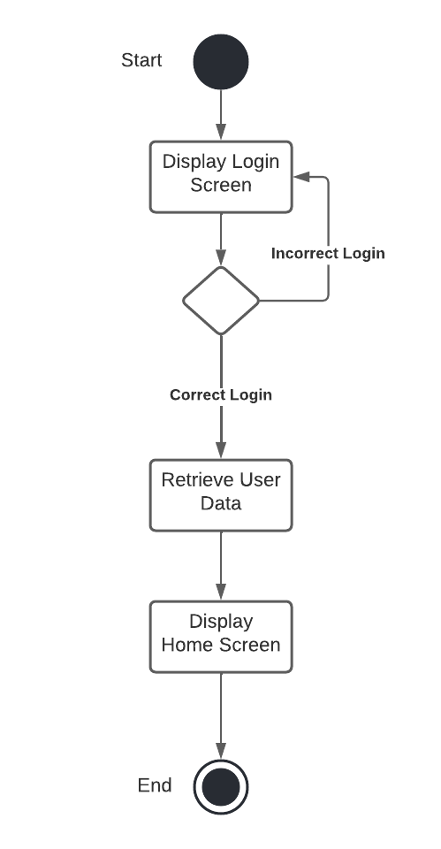

Use Case 2: User Creates Driving Appointment

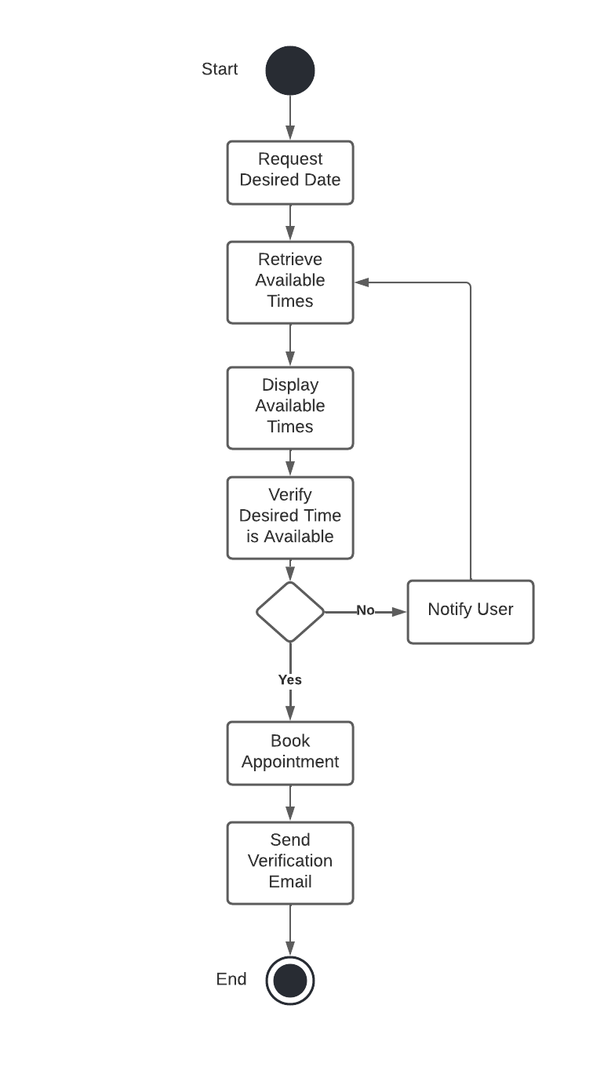

### UML Sequence Diagram

Sequence Diagram: User Books Driving Appointment

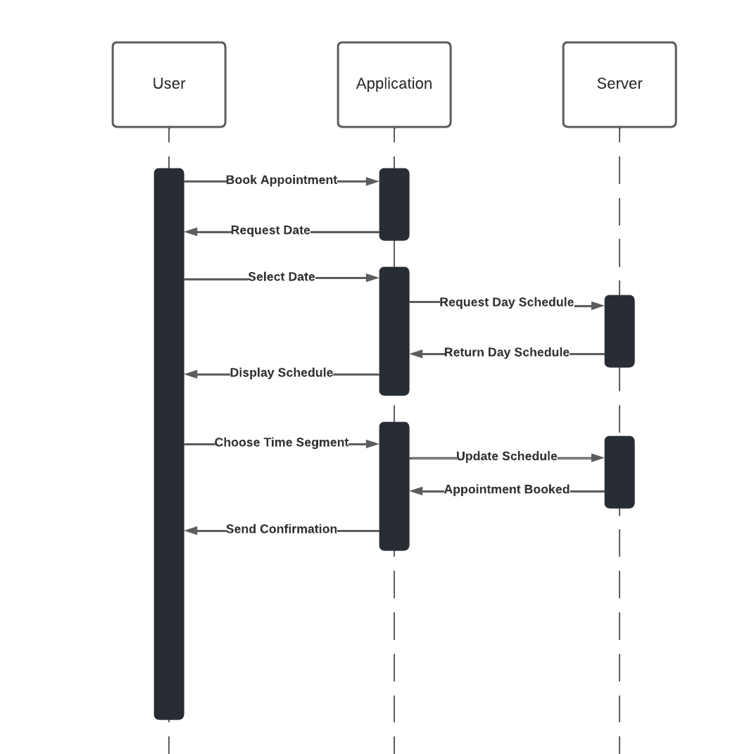

### UML Class Diagram

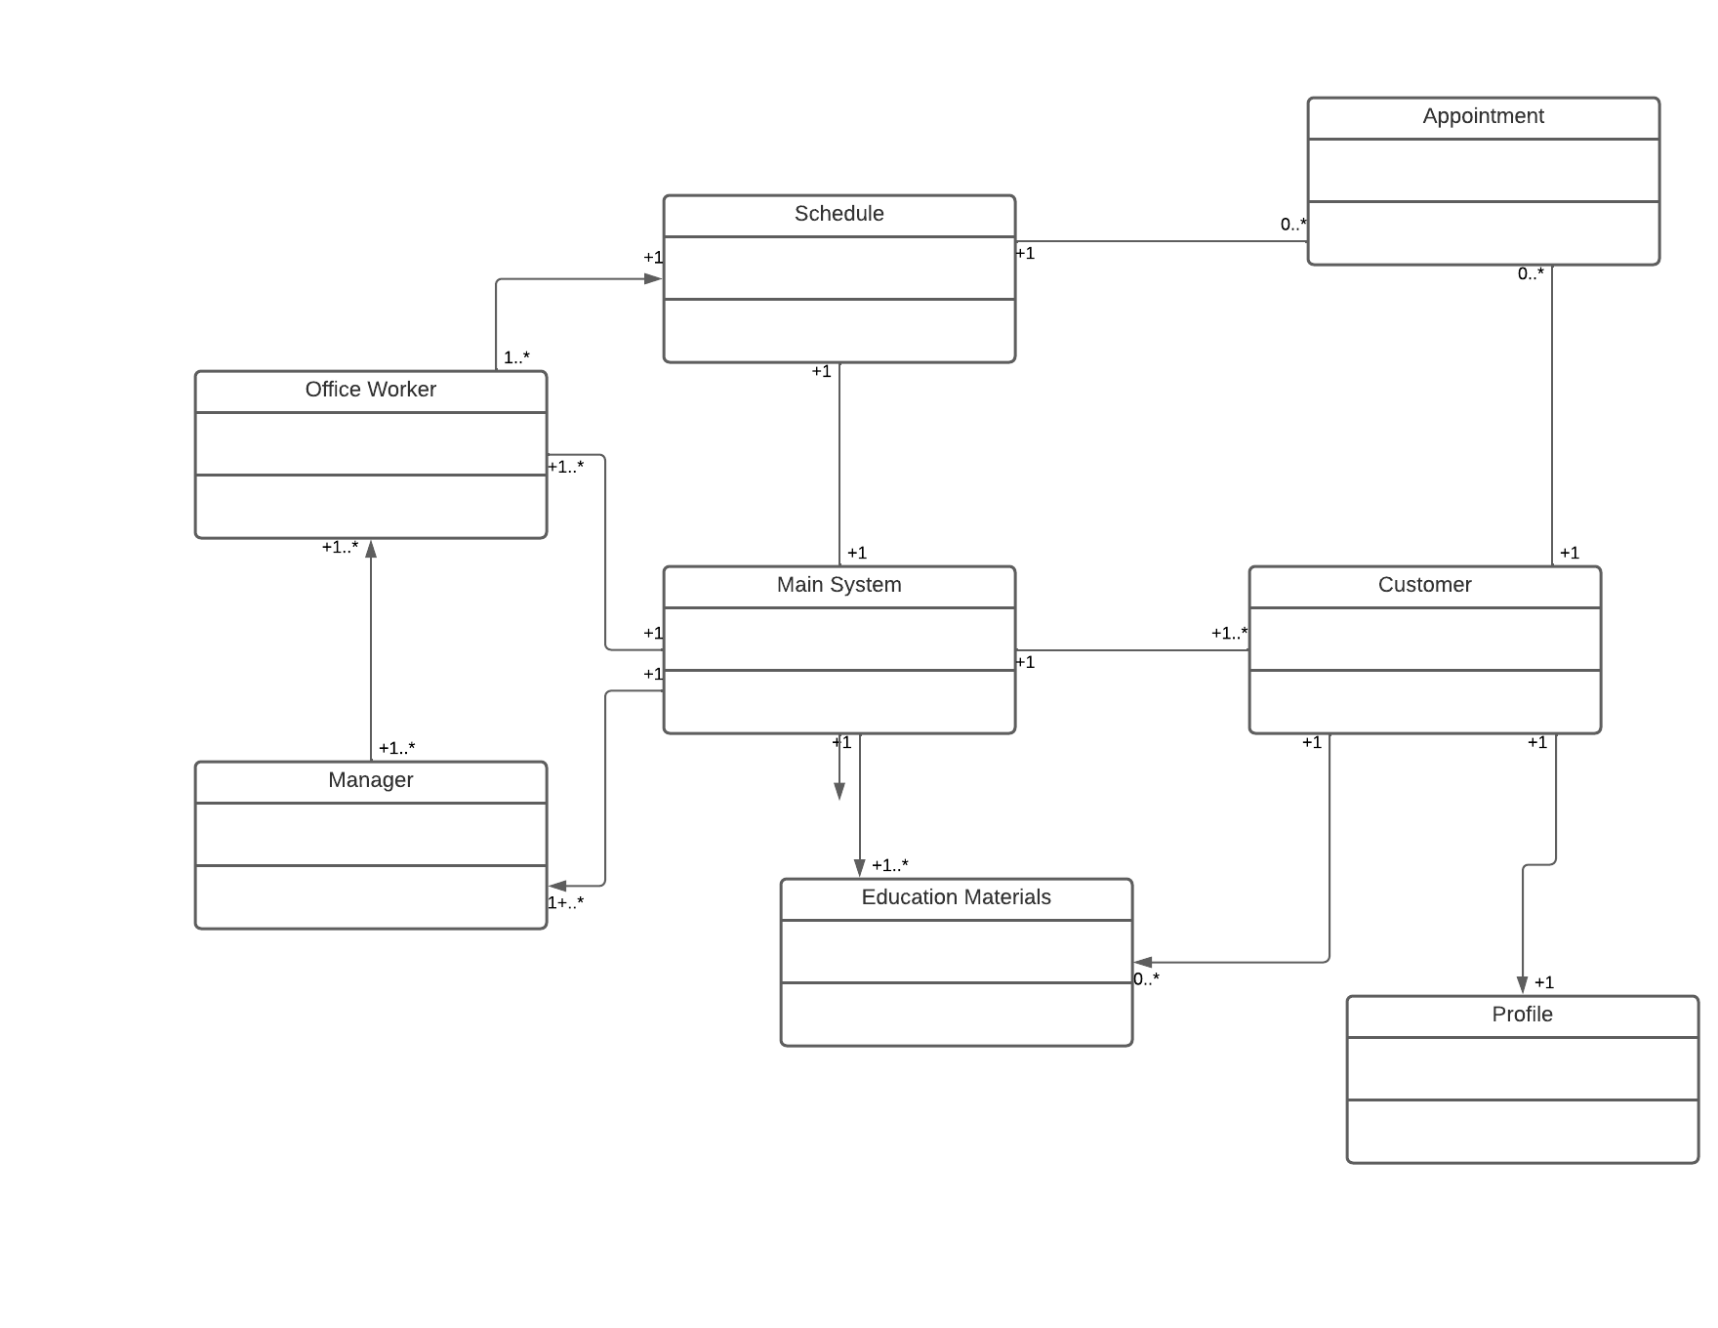

## Technical Requirements

* The system will require a cloud-based server system to communicate with user clients.
* The system will require both mobile and web-based apps
* The system will require a desktop app for use by on-site employees
* The system will require a secure access portal for use by mangement